David Mariani

650.483.4491

INSTRUCTIONS FOR adding a new parishioner to finalsite

Table of Contents

Add a new parishioner 3

Step 1: Login to Finalsite 3

Step 2: choose Constituents Manager from the drop down 4

Step 3: click on the add new constituents button 5

Step 4: fill in name section and household relationship 6

Step 5: fill in the parish info section and click update profile button 7

step 6: Click on the add a new address link, fill in the form, click Add address 8

step 7: click on the add a new relationship link & click browse button 9

Step 8: select parishioners group and select related profile 10

step 9: click on the add relationship button & repeat steps 7-9 if necessary 11

step 10: click on the groups tab, click on the more groups & click save mem.. 12

step 11: click on the roles tab & check the roles & click the save roles button 13

Step 12: click on the account tab and click on the create portal login button 14

step 13: fill in username and password and click the create login button 15

# Add a new parishioner

First launch your web browser and enter the following address: <http://angels.finalsite.com/admin.cfm>

## Step 1: Login to Finalsite

Login to Finalsite and choose **Constituents Manager** from the drop down

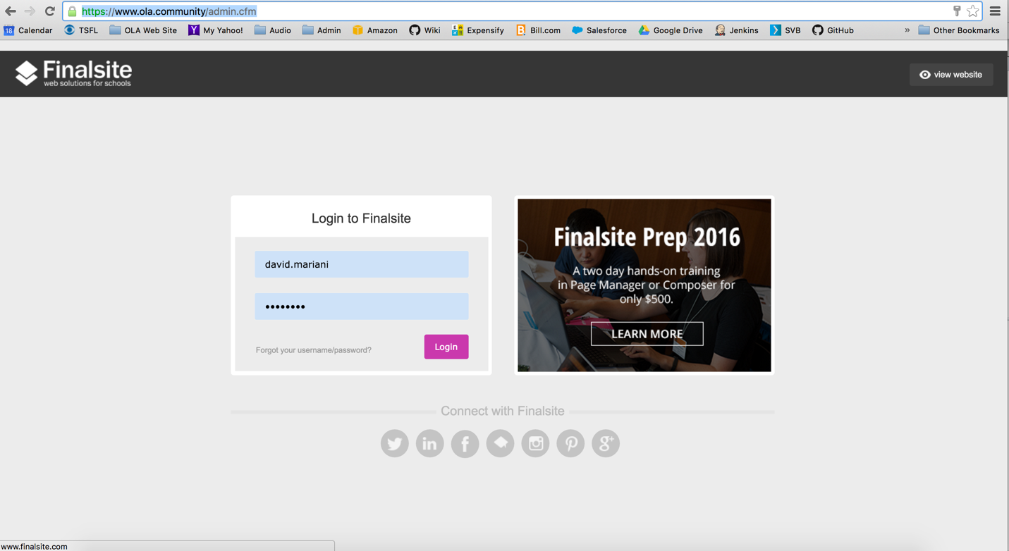

## Step 2: choose **Constituents Manager** from the drop down

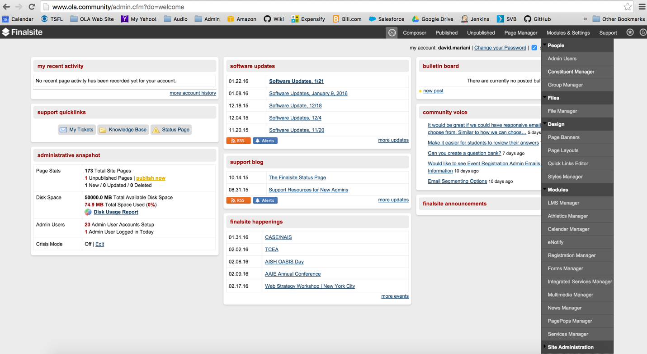

## Step 3: click on the **add new constituents** button

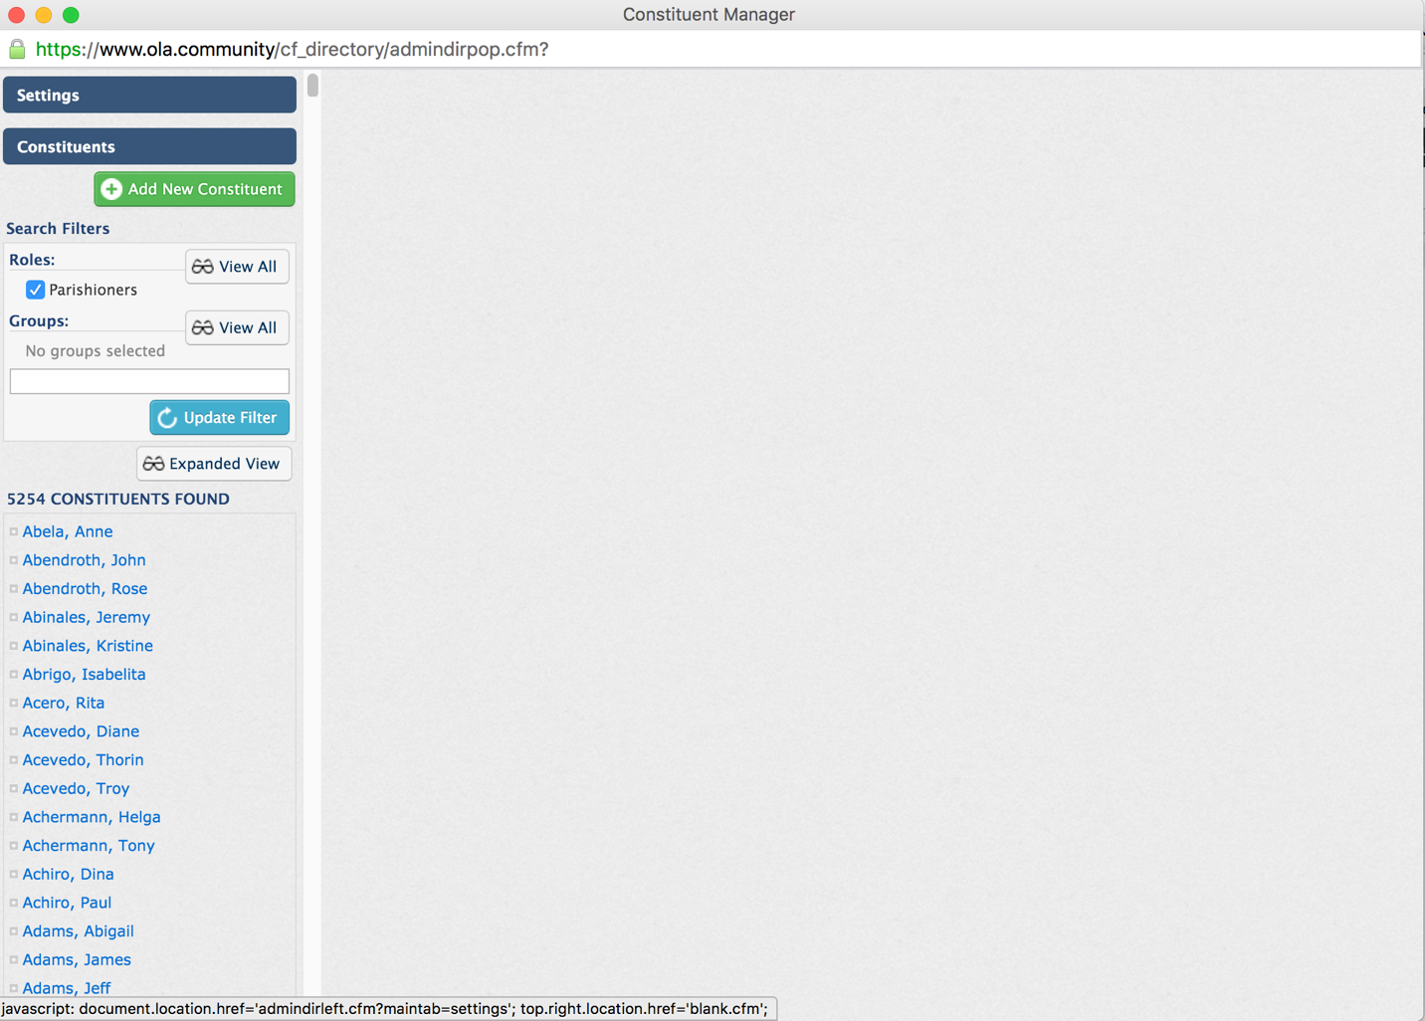

## Step 4: fill in **name, contact** sections and **household relationships** fields

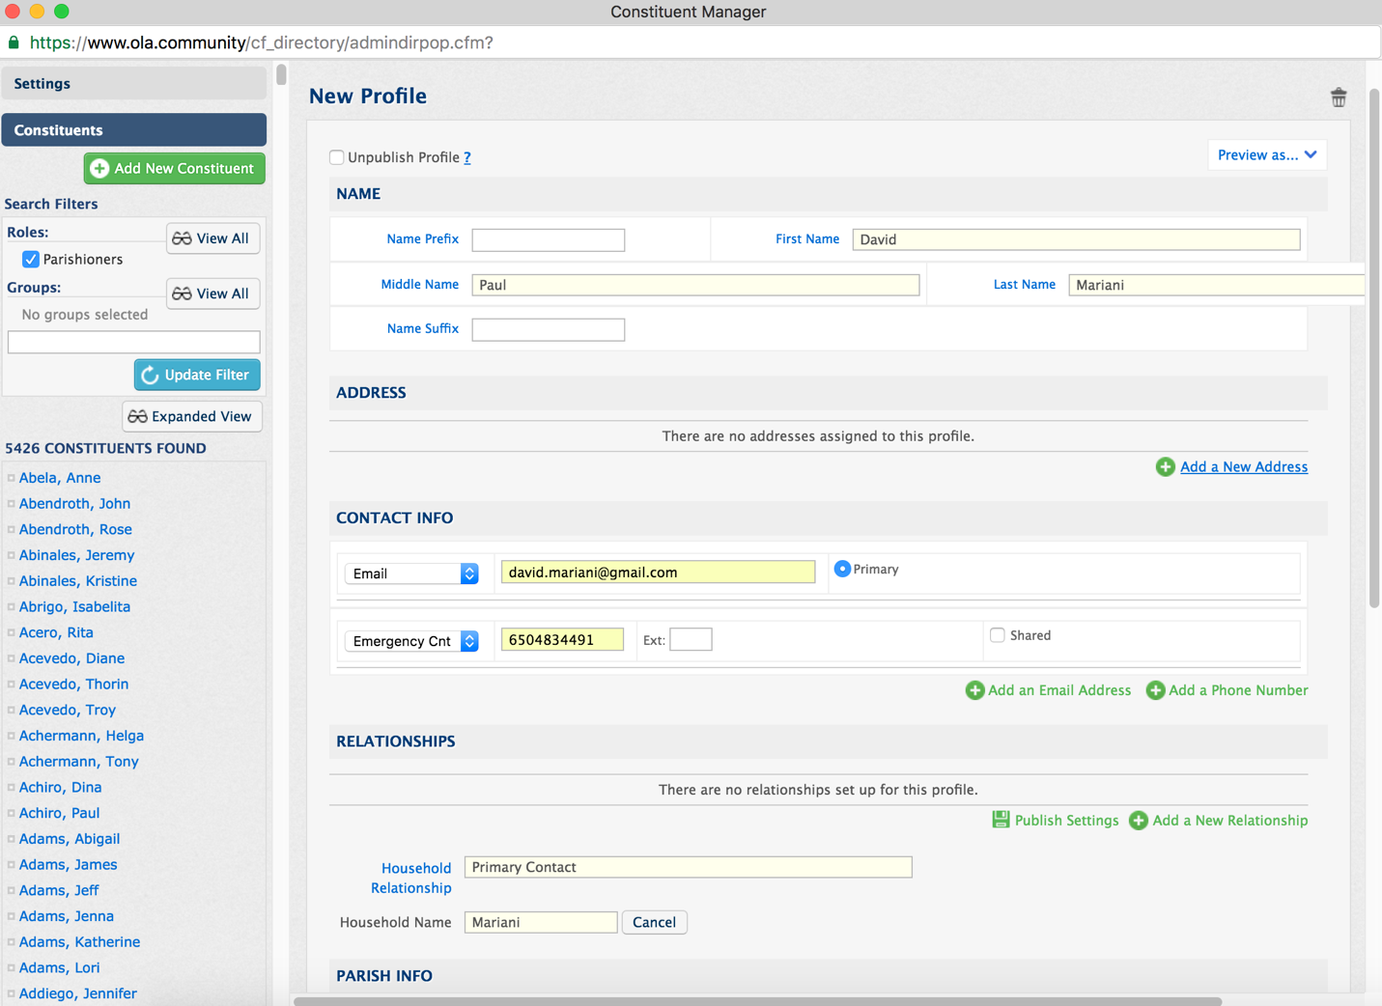

Note: Use “Primary Contact” for the head of household. Otherwise, use “Spouse” or “Child”. **Click on the ‘+New’ button to assign a household name for the Primary Contact. For all other family members, click the ‘Browse’ button and select the household name that you assigned for the Primary Contact’s profile. THIS IS VERY IMPORTANT!!!**

## Step 5: fill in the **parish info** section and click **update profile** button

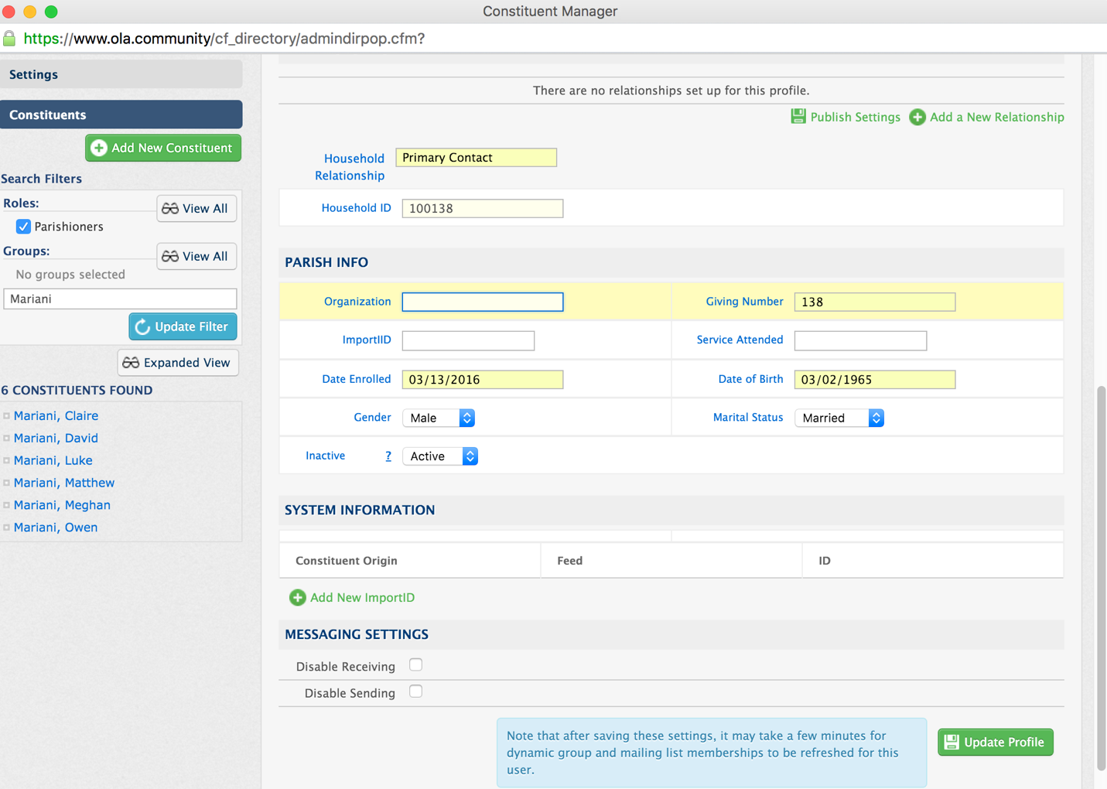

## step 6: Click on the **add a new address** link, fill in the form, click **Add address**

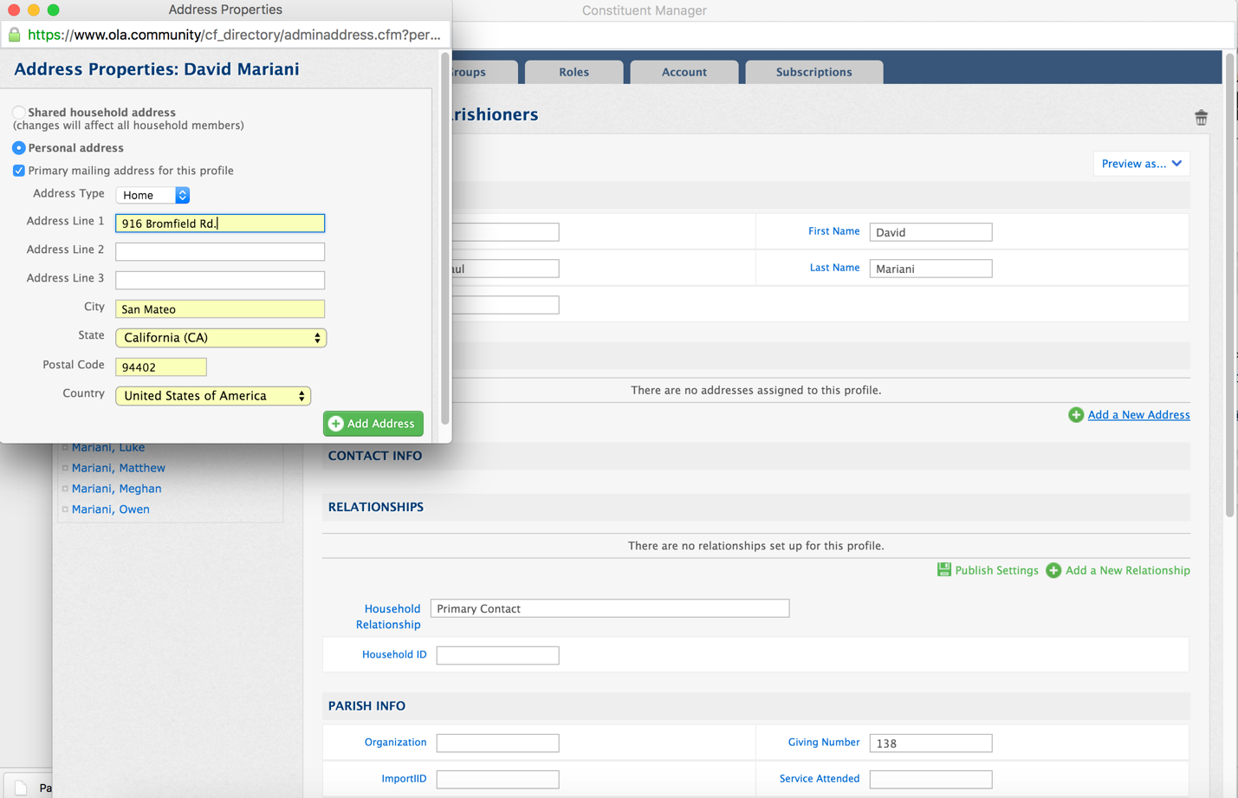

Note: Add each member of the family by repeating Steps 3-6 before proceeding to next step

## step 7: click on the **add a new relationship** link & click **browse** button

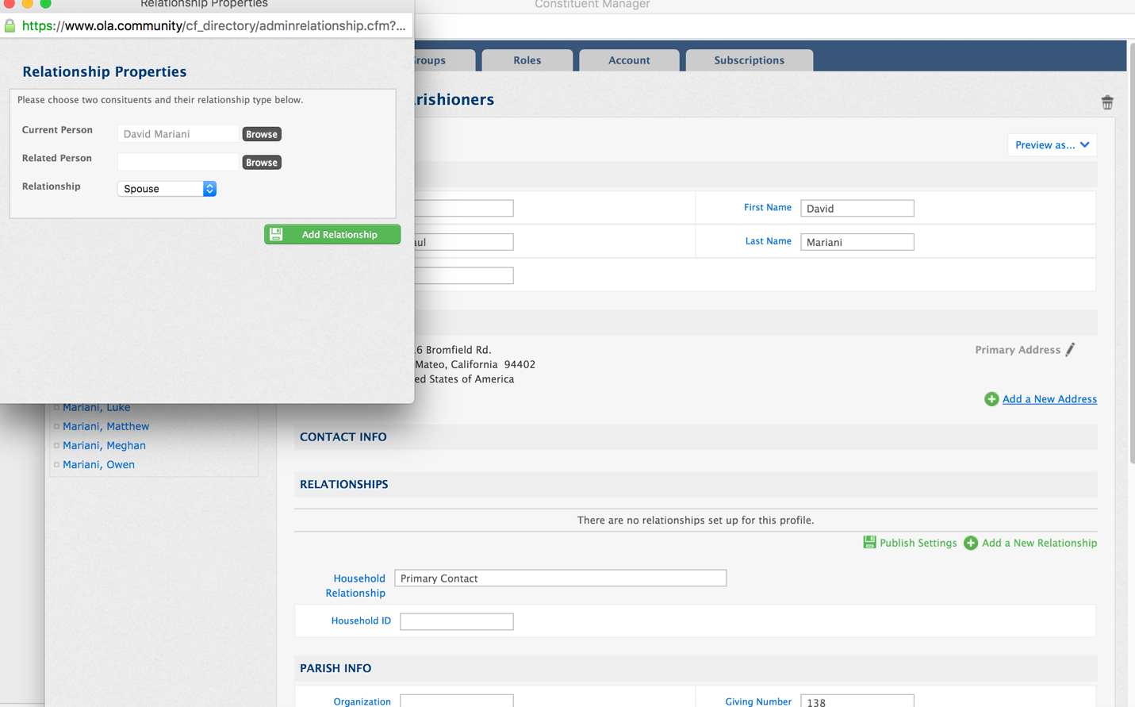

Note: This step is only necessary for the “Primary Contact” profile.

## Step 8: select **parishioners** group and select related profile

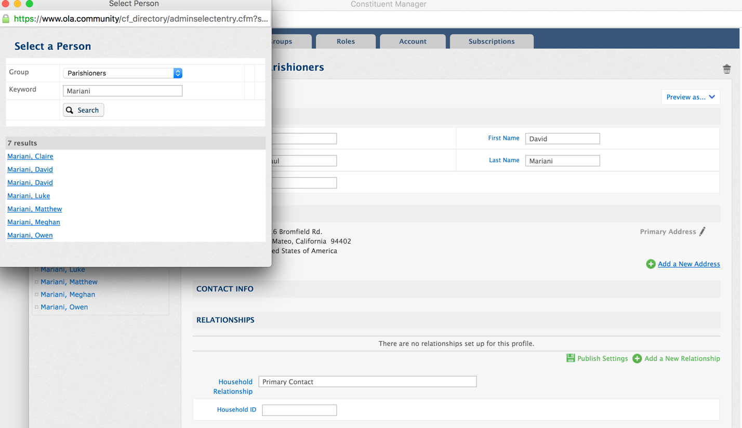

## step 9: click on the **add relationship** button & repeat steps 7-9 if necessary

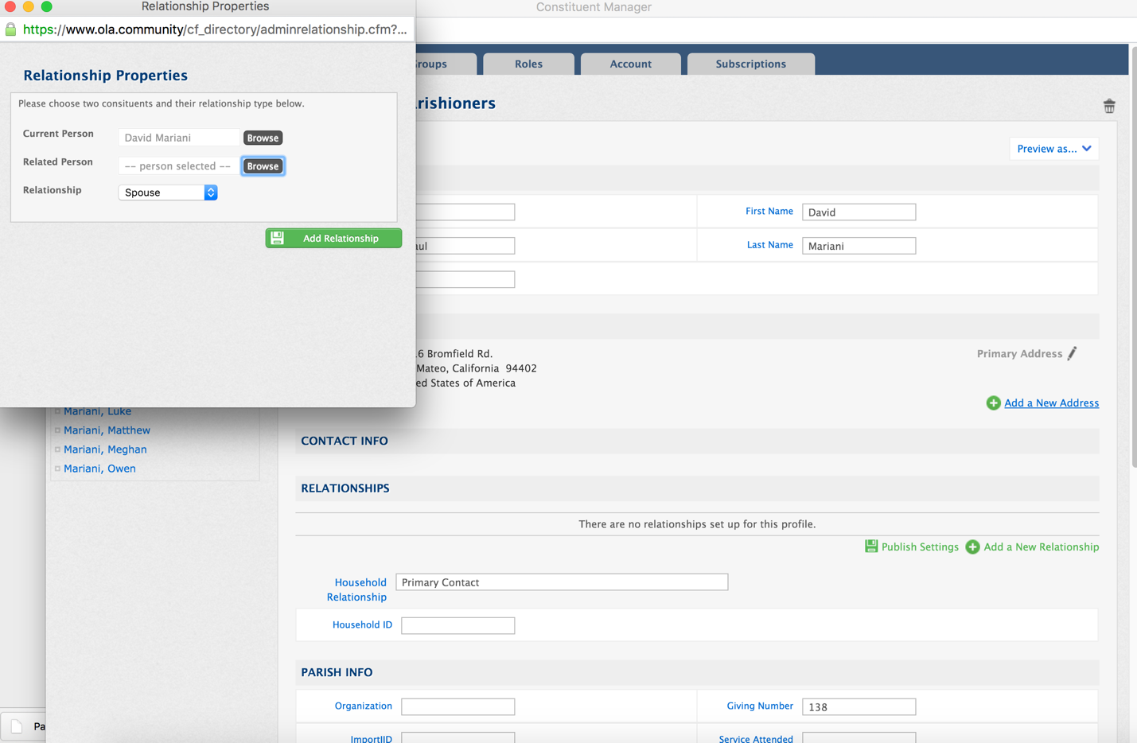

## step 10: click on the **groups** tab, click on the **more groups** & click **save mem..**

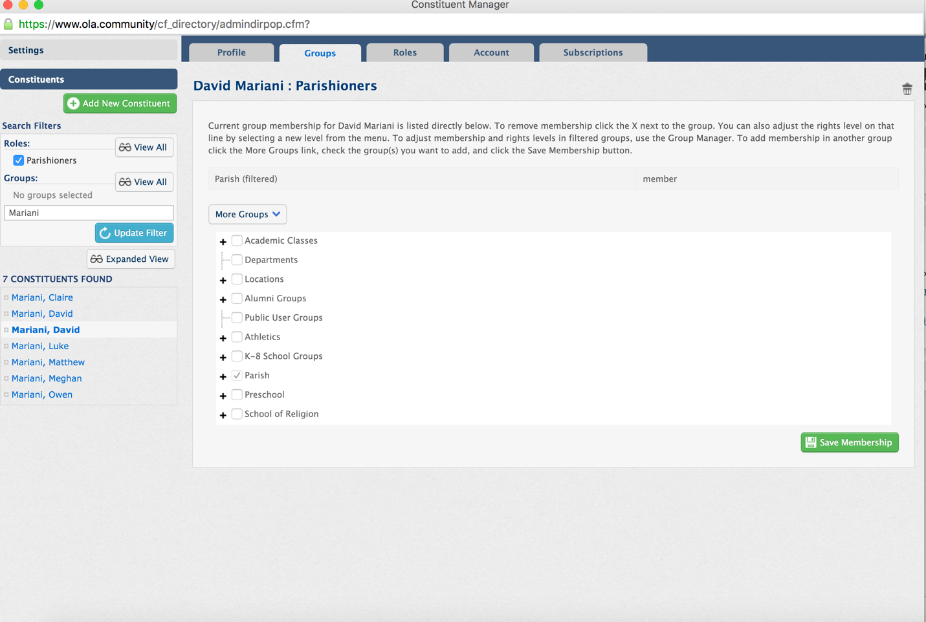

Note: If this is a K-8 school family, make sure to check the appropriate classes for parent or child

## step 11: click on the **roles** tab & check the roles & click the **save roles** button

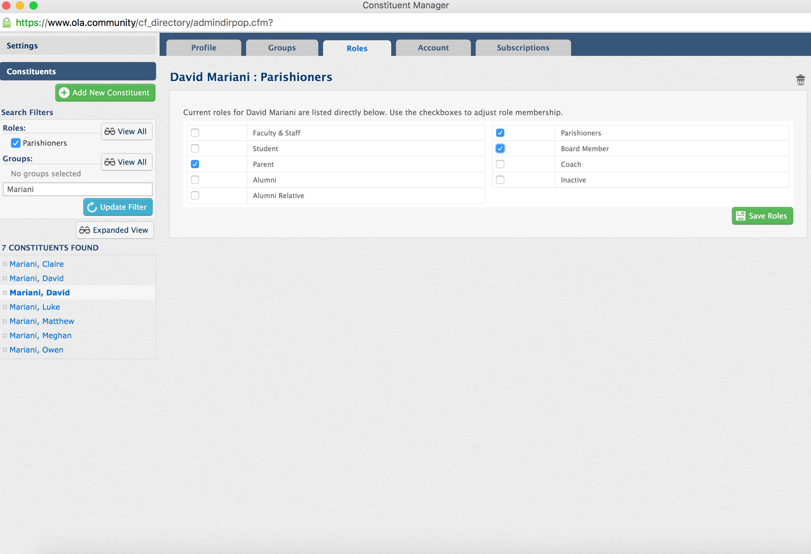

## Step 12: click on the **account** tab and click on the **create portal login** button

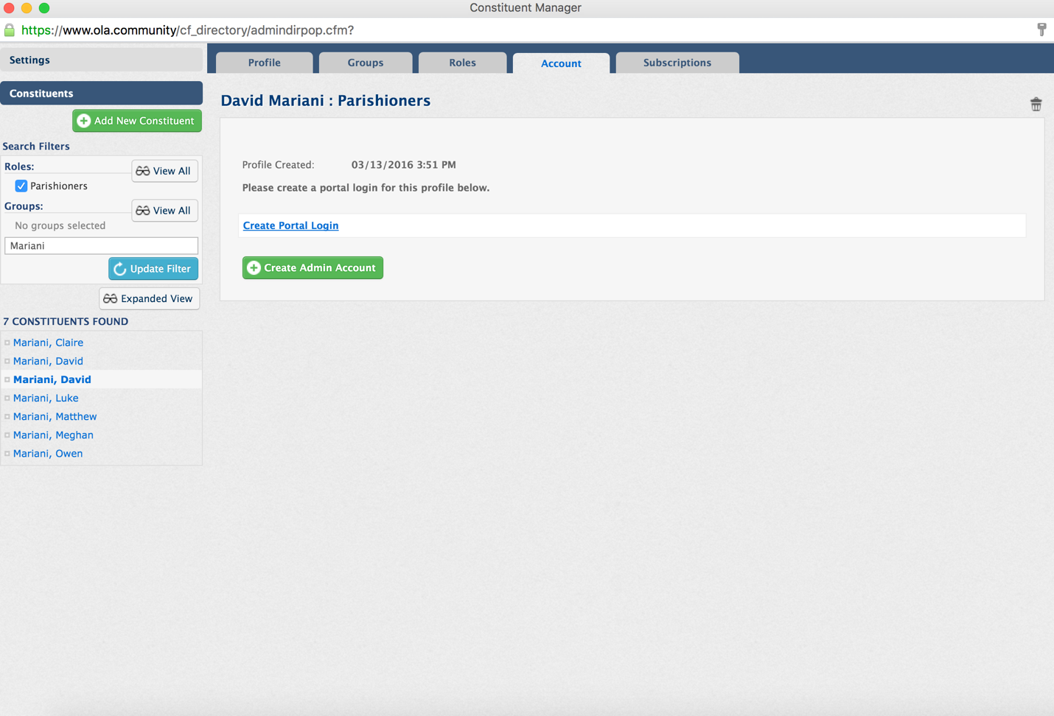

## step 13: fill in **username** and **password** and click the **create login** button

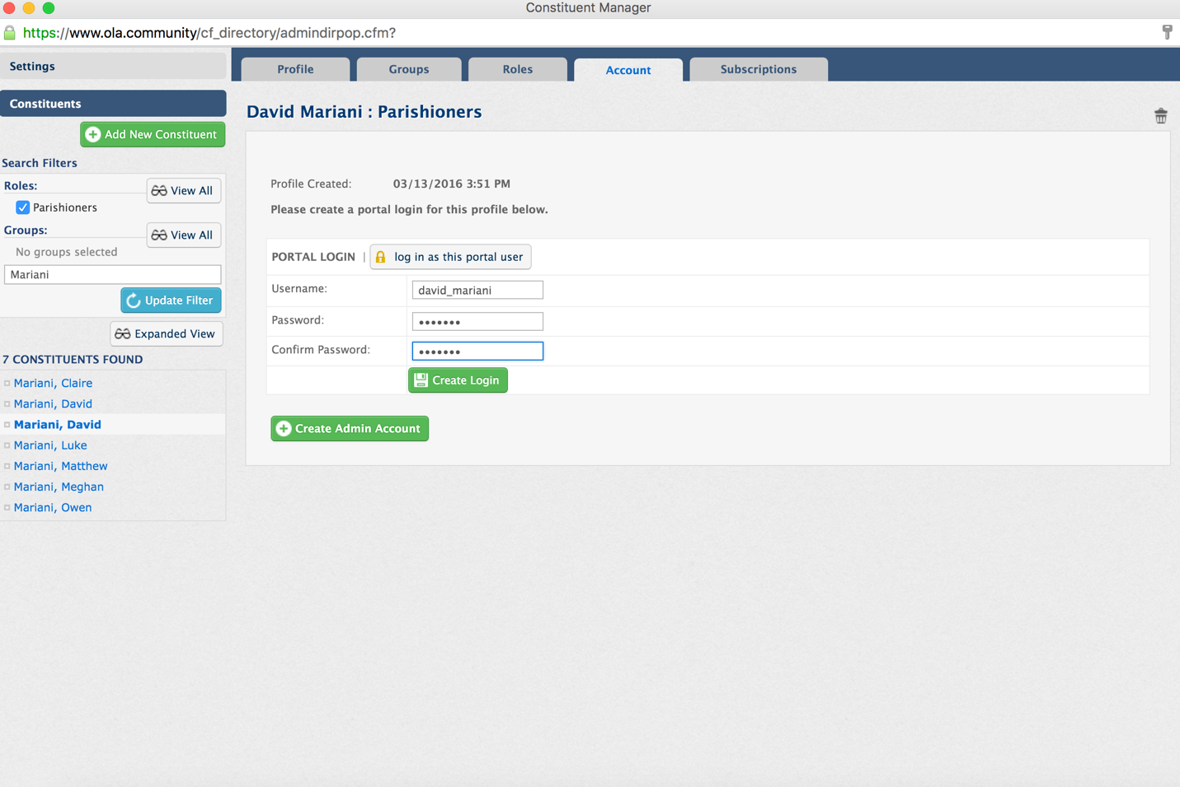

Note: User a **FIRSTNAME_LASTNAME** format for the **Username** field and choose “welcome” for the password